**CID Demographic Data Visualization Documentations**

This is the manual for how to clean up the raw data downloaded from Census Bureau website and implement data visualization of the organized data using R Shiny package. Please follow this process if you want to update the presentation with newer dataset. The time range of the existing data in the shared drive is the following (December 20th, 2019):

1. Education: 2009 – 2018
2. Income/Occupation: 2009 – 2018
3. Housing: 2009 – 2018
4. Demographic data (age, sex, population): 2009 – 2018
5. **Before running the program (when you want to update the data files)**
   1. Please download the right data file for each category.
      1. You can download the data files from the U.S. Census Bureau. You can access the data from the following link: <https://data.census.gov/cedsci/?q=&g=>
      2. Search for the data you want to download/update by table number (DPXX). Please refer to the following table names by each category:

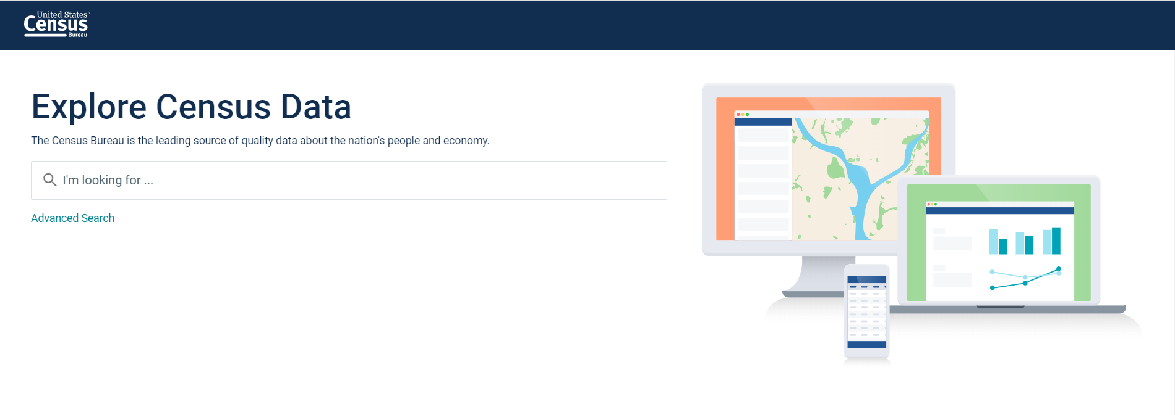

* + - 1. Education: DP02
      2. Income/Occupation: DP03
      3. Housing: DP04
      4. Demographic data (age, sex, population): DP05
    1. For the analysis the program uses American Community Survey (ACS) **5-Year Estimates** (not 1-Year Estimates). You can 1) select 5-Year Estimates option in the Product dropdown menu. Then 2) click the customize table button to subset CID area using the Tract information.

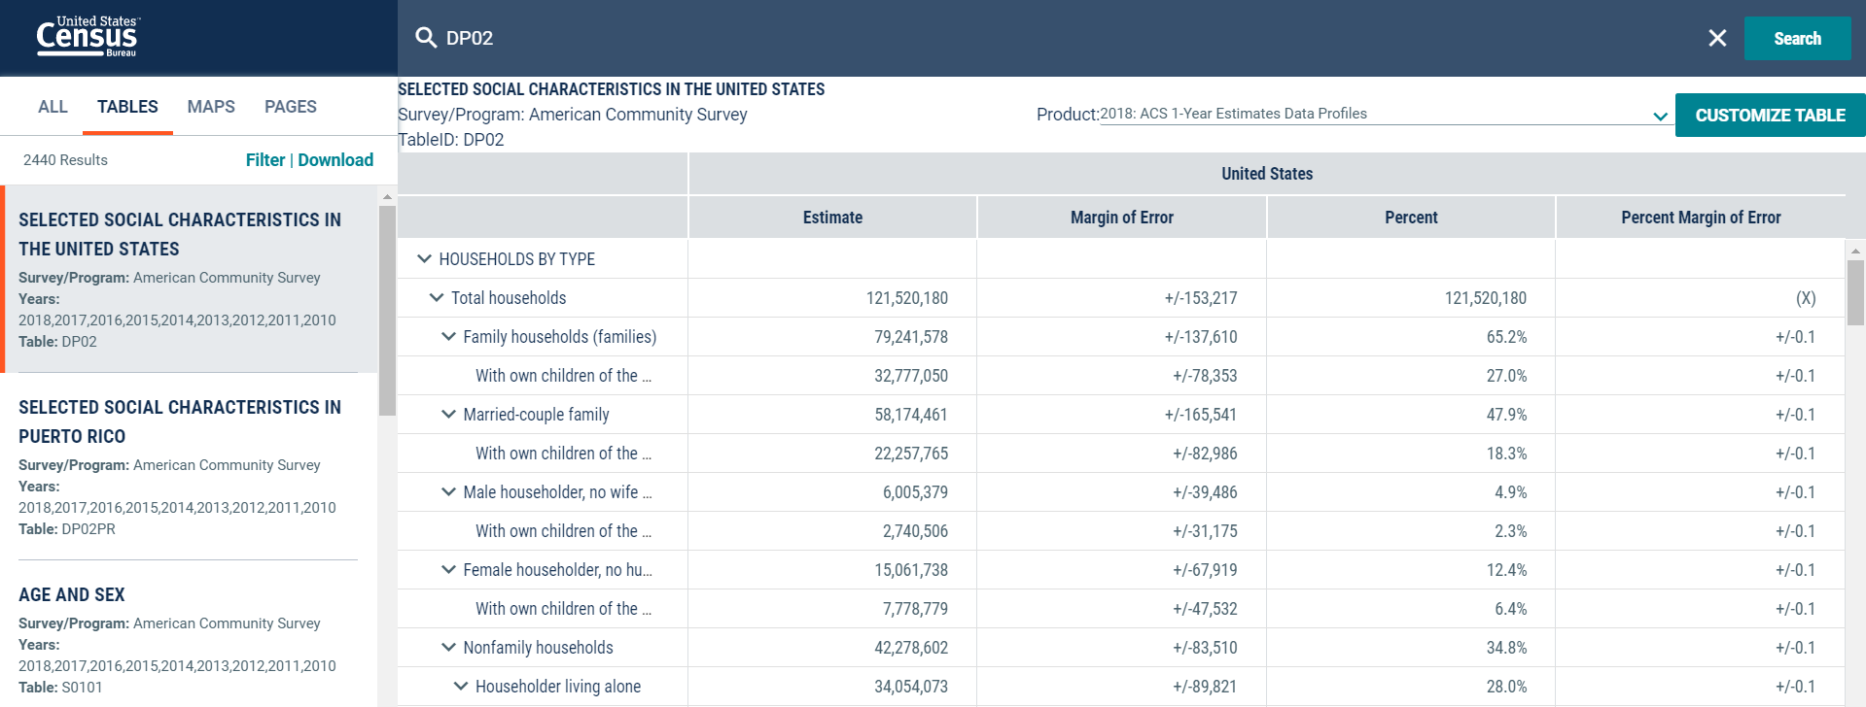

2

1

* + 1. Once you get to the customize table section, subset the geographic area according to the following order
       1. Click Geographies.
       2. Select “Tract” in Geography dropdown menu.
       3. Select “Missouri” in Within State dropdown menu.
       4. Select “St. Louis city, Missouri” in Missouri dropdown menu.
       5. Select “Census Tract 1255, St. Louis city, Missouri” and “Census Tract 1256, St. Louis city, Missouri” in the St. Louis city, Missouri dropdown menu.
       6. Click “Close” to finalize the selection.

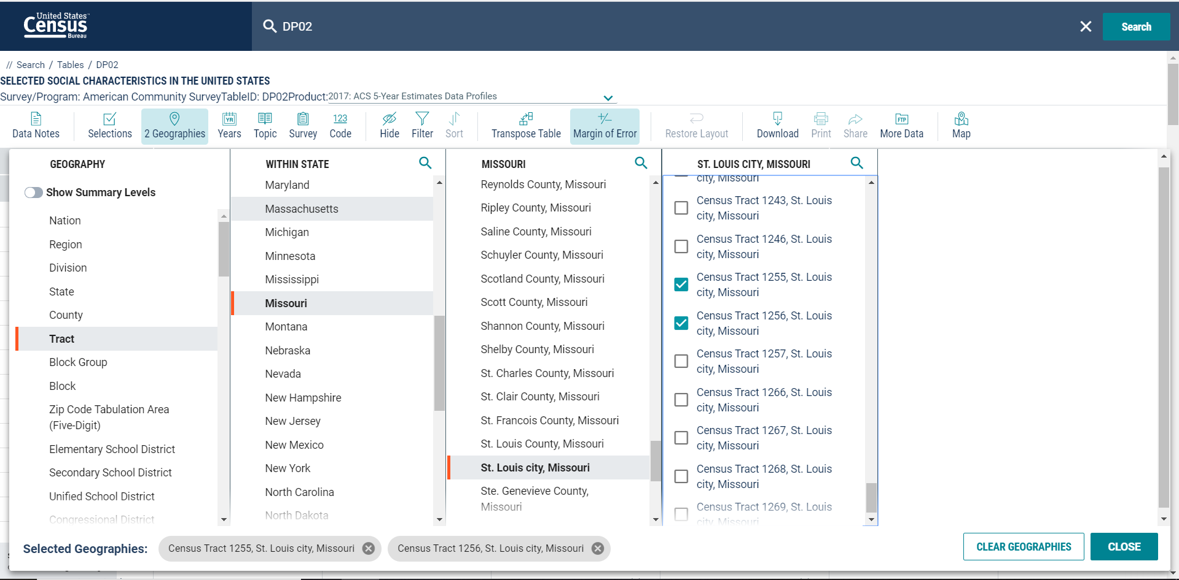

6

5

4

3

2

1

* + 1. Select download option on the top of the table and check the years you would like to look for. Click download button on the bottom right corner once you finished selecting the years. Then click the greyed area to access the “Download Now” banner.

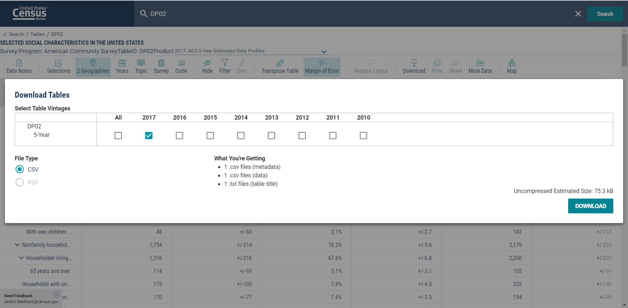

4

3

2

1

* + 1. Click “Download Now” on the banner, and you will get a .zip file with the actual data (in .csv), metadata (in .csv), and table title (in .txt).

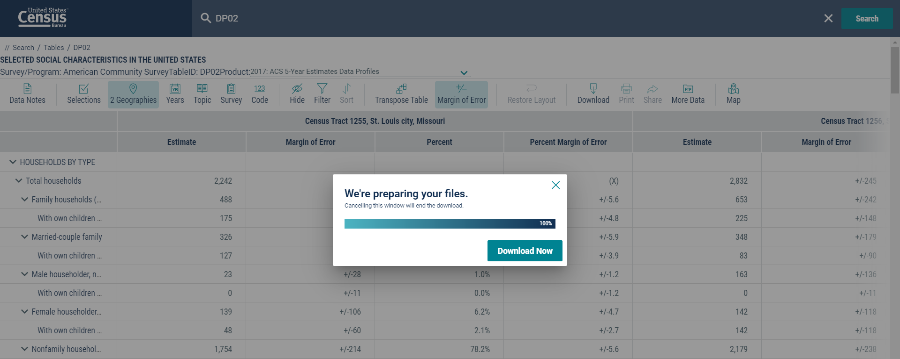

* 1. Please place the file into designated folder.
     1. Once you unzip the file, get rid of the metadata and .txt file. What we only need is the .csv file with “…_data_with_overlays_...”
     2. Place the .csv file into the designated folder. For example, if you downloaded a DP02 file, place it in the DP02 folder.
     3. Follow the naming convention referring to the file names of the existing data. What you need to do here is mostly erasing the “_data_with_overlays_...” part.
  2. You need R and RStudio in your computer to run this program. Please install R first before installing RStudio. You can download and install the software from the following links:
     1. R: <https://cran.r-project.org/bin/windows/base/>
     2. RStudio: <https://rstudio.com/products/rstudio/download/>

1. **Organize the raw data into an analyzable format using dataOrganizer**
   1. Click “Data_Cleaning” R Proj file in CID Demographic Data folder.
   2. Once RStudio runs, click dataOrganizer.R file in the Files panel at the bottom right.

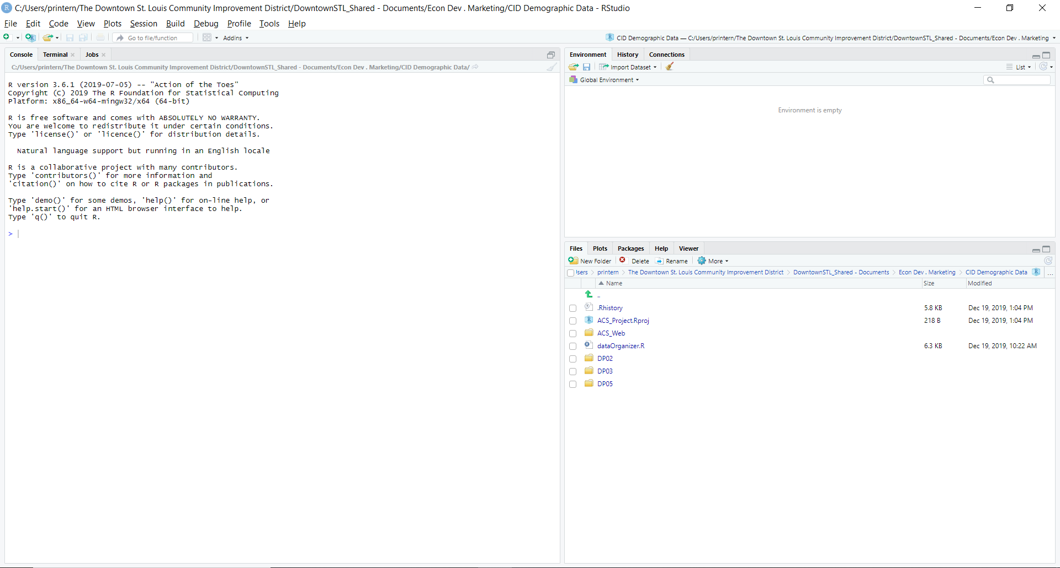

* 1. Run the code script by pressing “Ctrl+Shift+Enter”
     1. It will take some time downloading and installing some packages necessary for running the program. So do not panic if the Console is filled with lines of red texts.
  2. Type in the range of the years when prompt pops up in the Console panel at the bottom left.

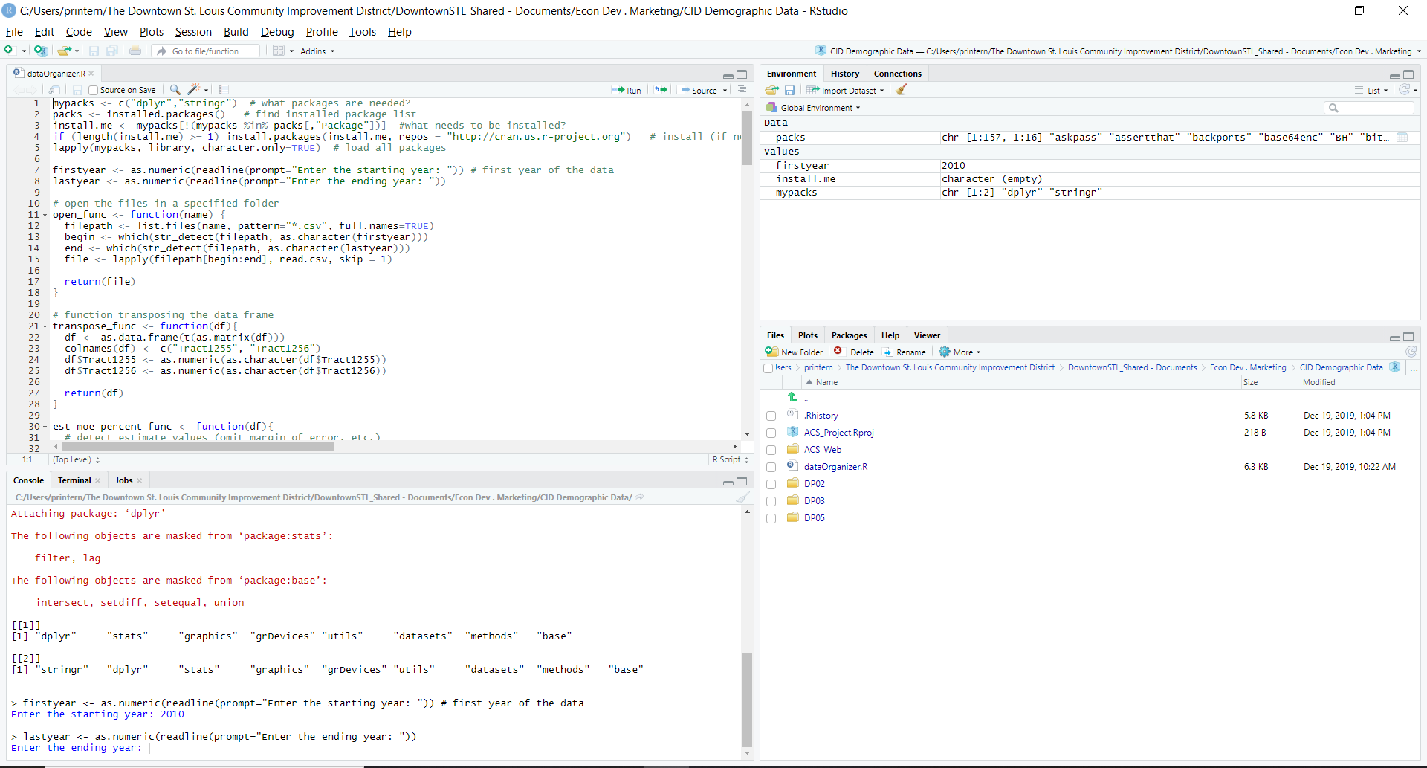

* + 1. Enter the starting year: year your data begin with (e.g. 2009)
    2. Enter the end year: year your data ends with (e.g. 2017)
  1. Wait until the code finishes running. Check for the error messages in the console if any. If none, organized data file would be created in “ACS_Web” folder in .csv format (“age_sex”, “edu”, and “income”).

1. **Run the data visualization slide and (re)publish it online.**
   1. Get into the ACS_Web folder.
   2. Click “Presentation” R Proj file
   3. Once RStudio runs, click “ACS_Web.Rmd” file in the Files panel at the bottom right.

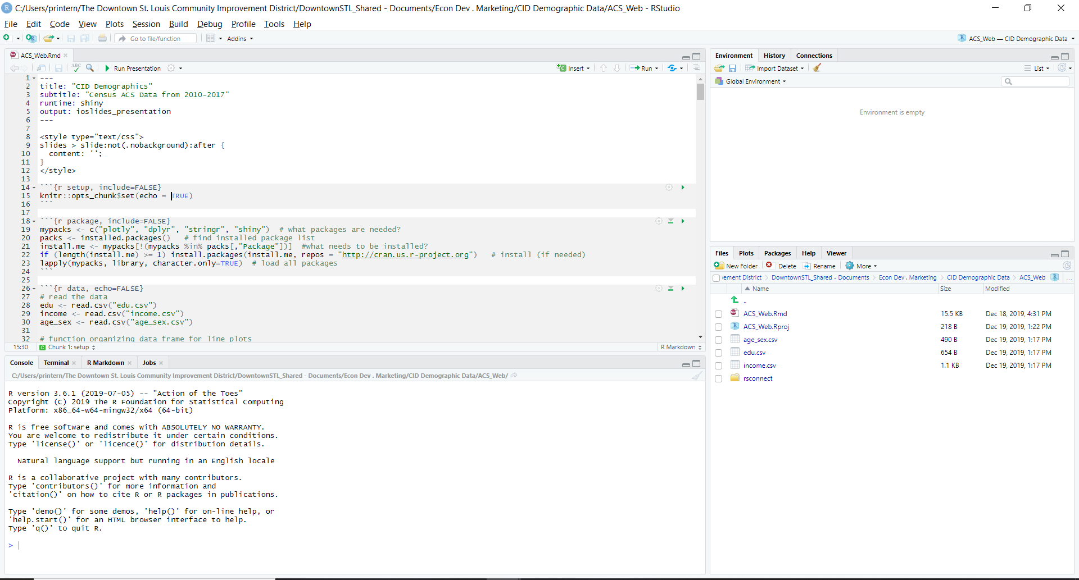

* 1. *(First time process. Skip from* ***d*** *to* ***j*** *if it is not the first-time publishing from your computer)* Click the blue button at the top right corner of the left top panel.



* 1. *(First time process)* Select “Manage Account” option in the dropdown menu.

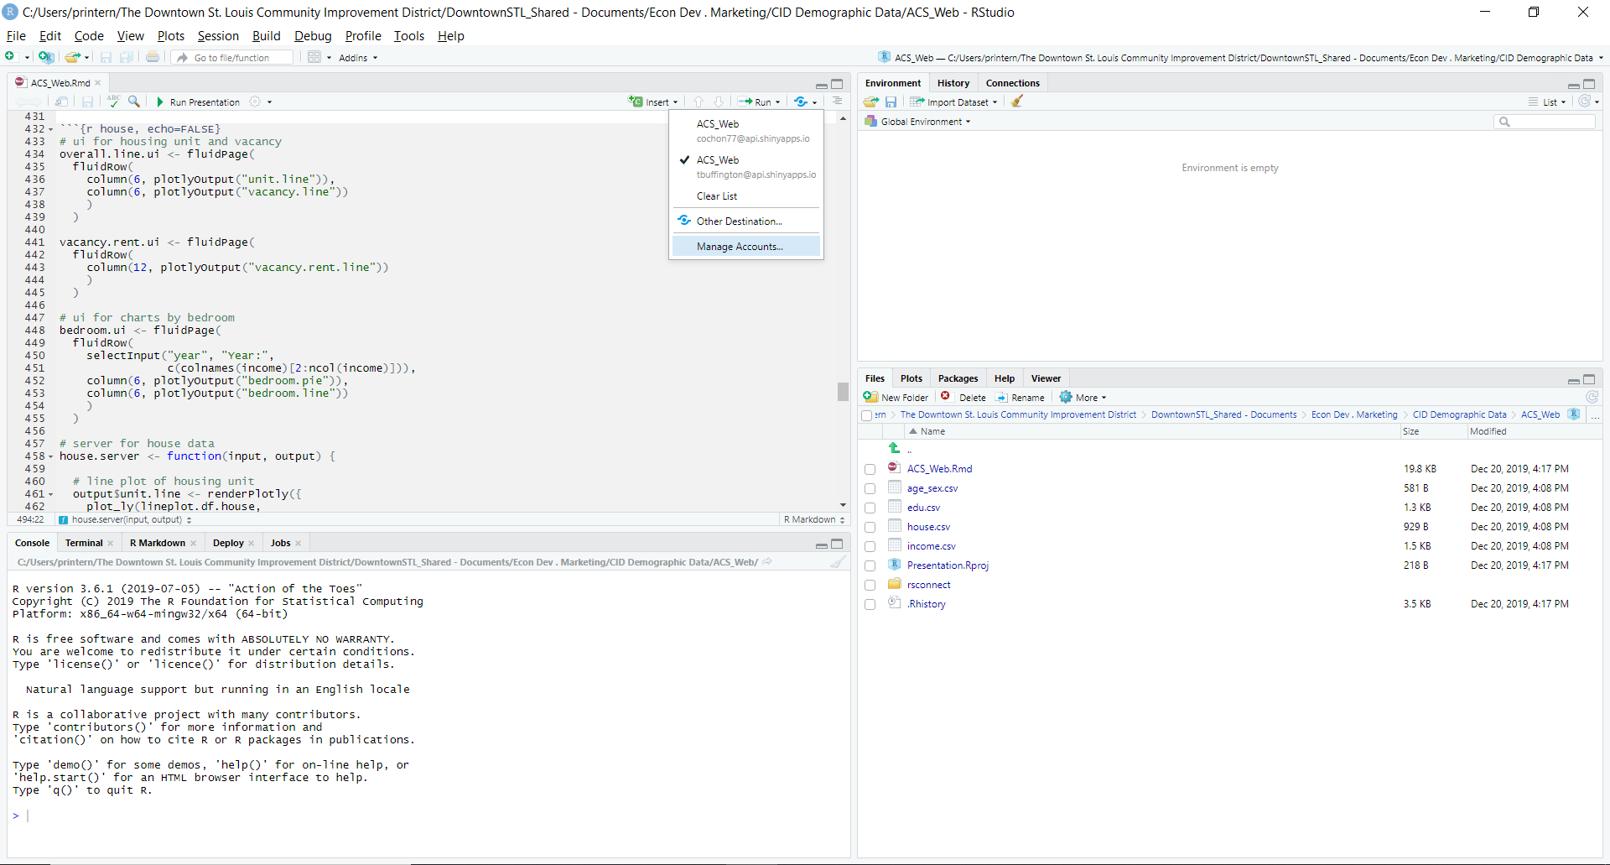

* 1. *(First time process)* Click “Connect” and select “ShinyApps.io” option in the following banner.

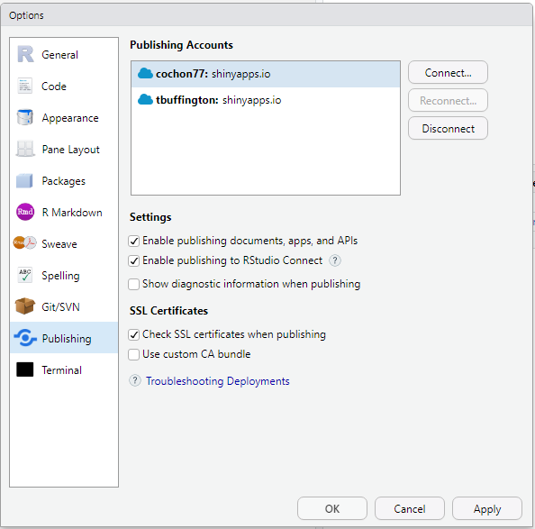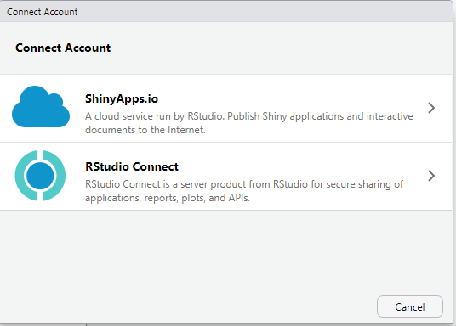

* 1. *(First time process)* Go to your shinyapp.io Dashboard. Click the top right corner with a person icon to access your Tokens. 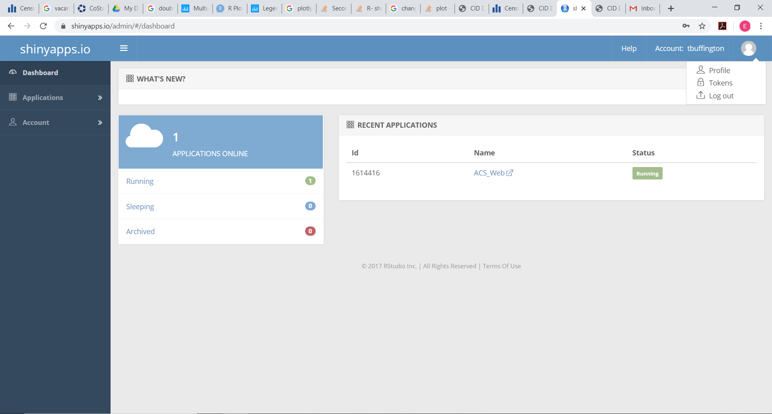
  2. *(First time process)* Click “Show” button to see the Token.

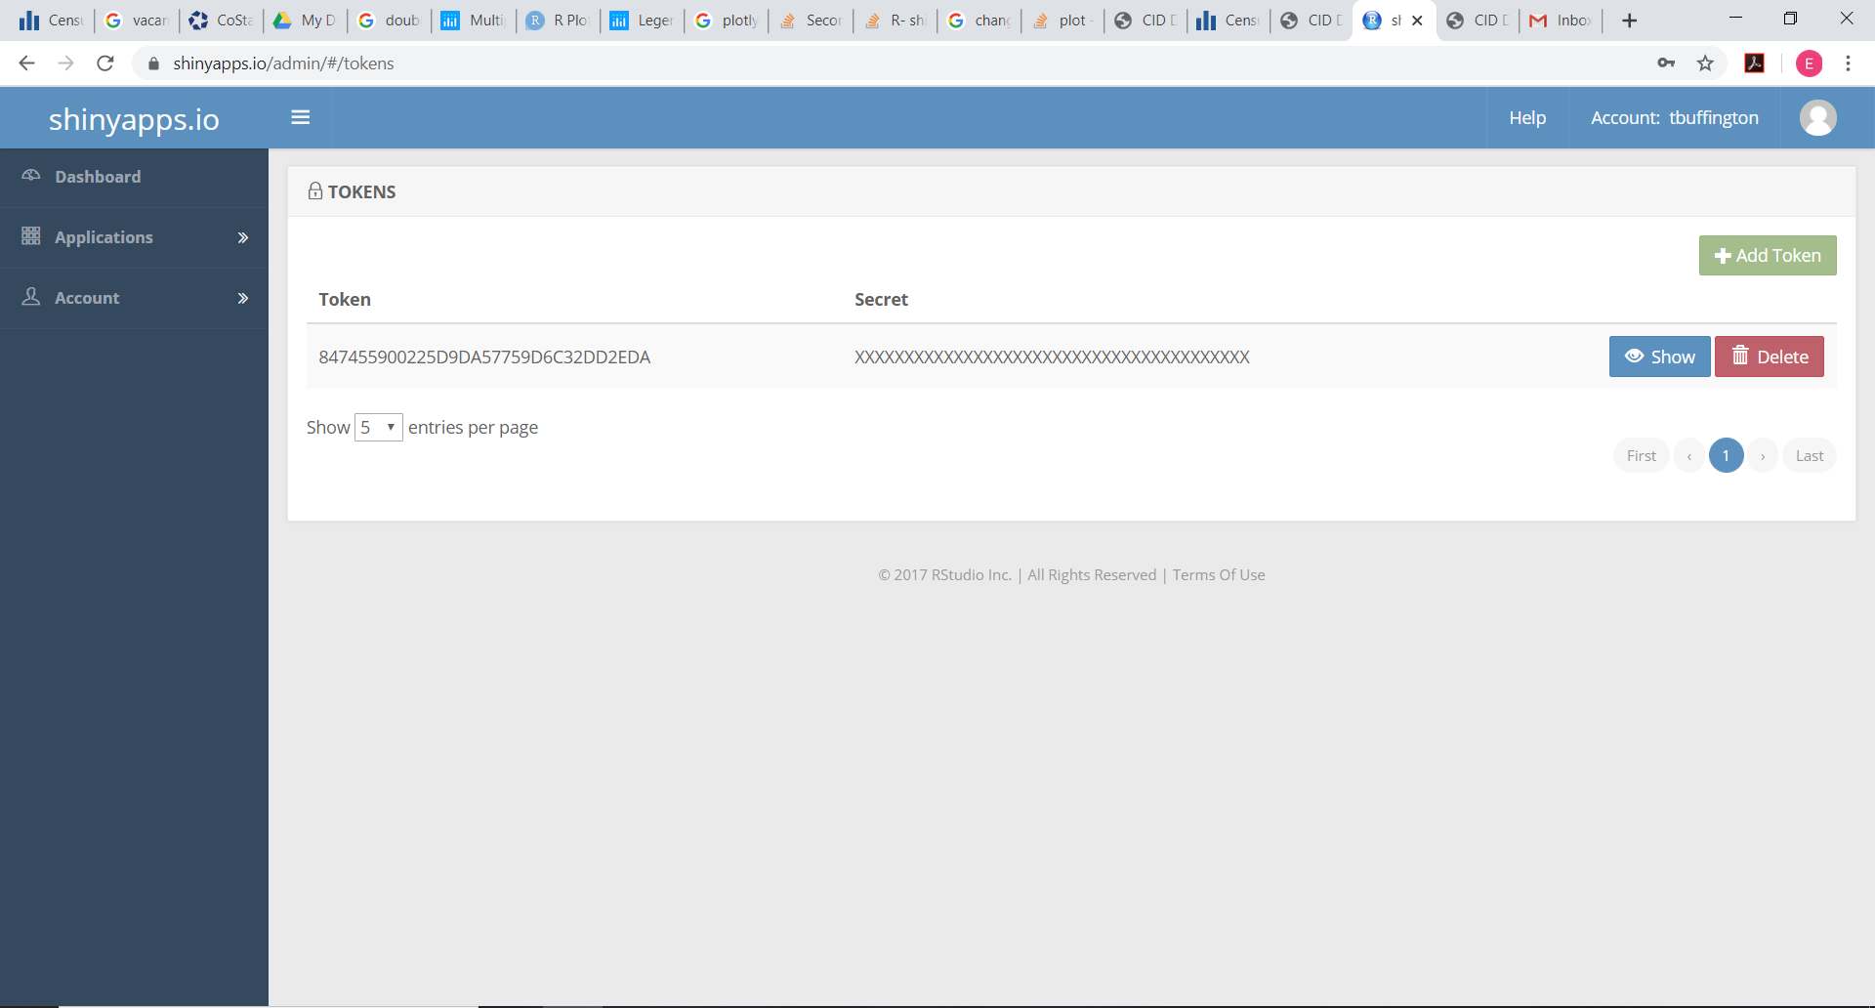

* 1. *(First time process)* Click “Show Secret” button in the popup banner and then copy the entire thing to the clipboard.

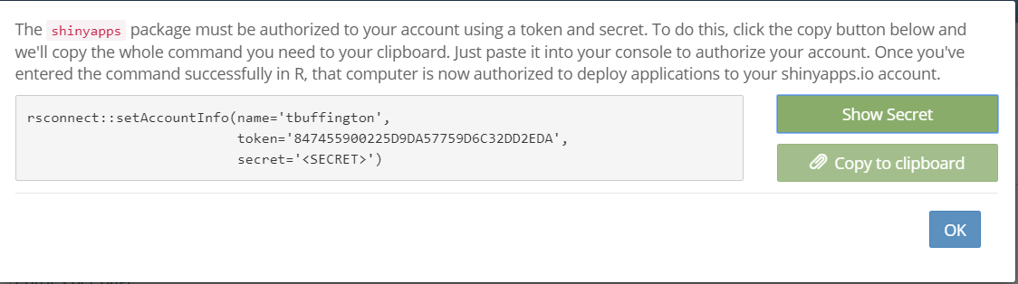

2

1

* 1. *(First time process)* Go back to the RStudio. Paste the copied text to the white text box, and then click “Connect Account” to connect your RStudio with your shinyapp account.

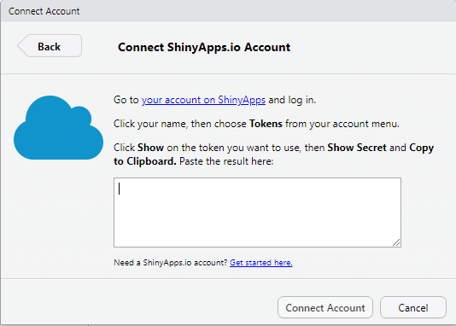

2

1

* 1. Click “Run Presentation” button on the top.



* 1. Go through the slides and check for the errors if there is any.
  2. Click “Republish” button on the top.

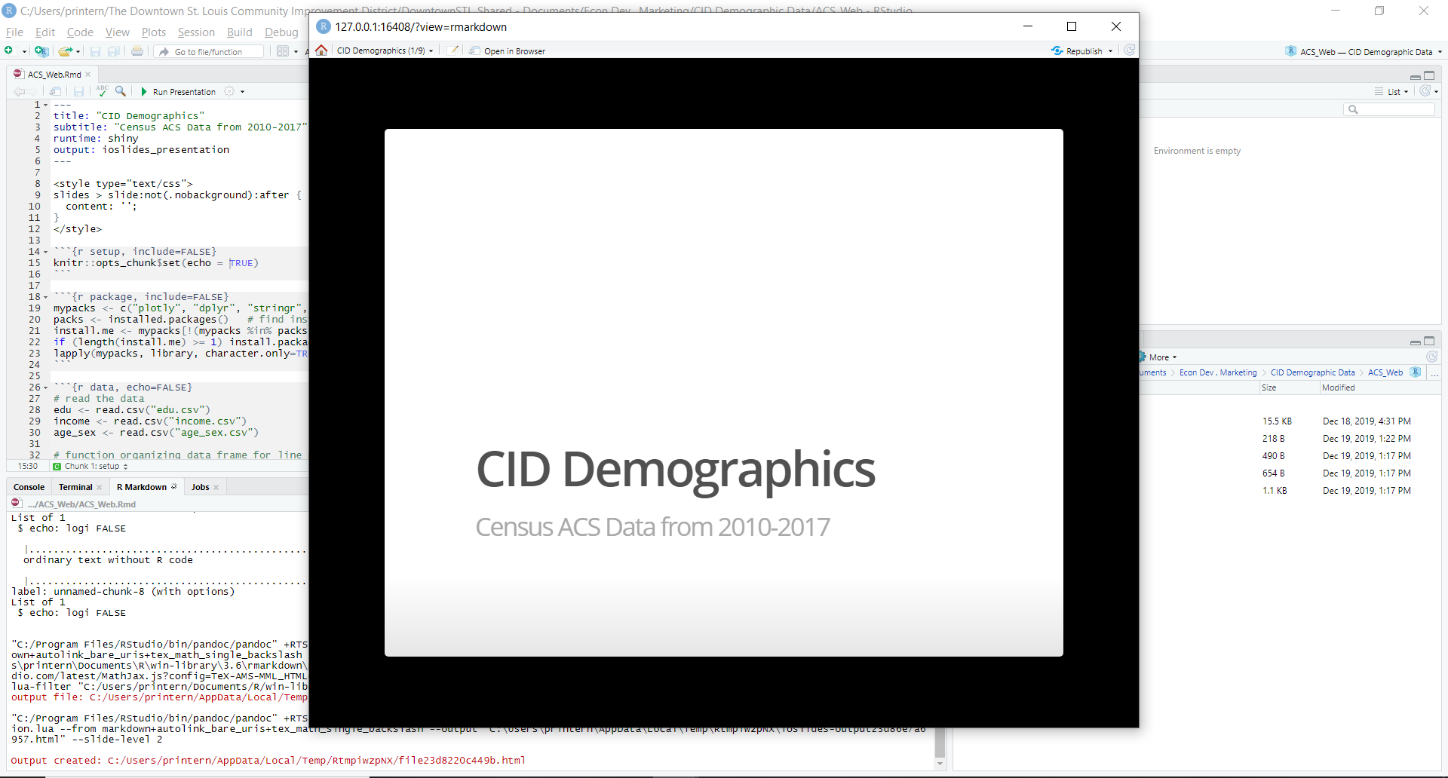

* 1. Check all the data (.csv) and .Rmd files on the left side of the banner. Then click “Publish” button at the bottom of the banner.

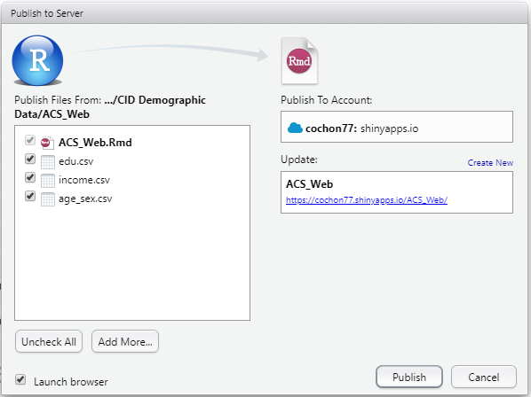

1

2

* 1. Once it is done processing, the produced output will popup in the browser. You can access the presentation in the following link: <https://tbuffington.shinyapps.io/ACS_Web/>